Taco Box
Sean Brooks  Student  Ithaca, NY, USA  seb362@cornell.edu | Annie Fu  Student  Ithaca, NY, USA  af397@cornell.edu | Shea Murphy  Student  Ithaca, NY, USA  sm967@cornell.edu | Saaqeb Siddiqi  Student  Ithaca, NY, USA  ss3759@cornell.edu

ABSTRACT
People are constantly searching for new avenues of sharing and preparing food, as exemplified by the evolution of brick and mortar restaurants to drive-thrus, Grubhub and Ubereats, and food trucks. The Taco Box is the latest in a revolutionary string of on-the-go meal preparation methods. Building off of made-to-order, customizable restaurant models including those of Chipotle and Blaze Pizza. With this project, we hope to apply innovative techniques to create a more compact, more efficient, and hands on food creation machine than any the industry has seen before.

INTRODUCTION
Casual, quickly made street food, especially tacos, is often served from food trucks or sidewalk stands for the sake of convenience and saving time. When they are served in restaurants, they can reach high costs and lose their appeal as cheap, quick eats. Since rapid prototyping makes cutting-edge innovation and design accessible to the everyday person, albeit occasionally at low quality and low cost, automating a complete dining experience to serve different types of tacos, a popular, easy-to-assemble food, allows us to think about the role of the chef in food preparation.
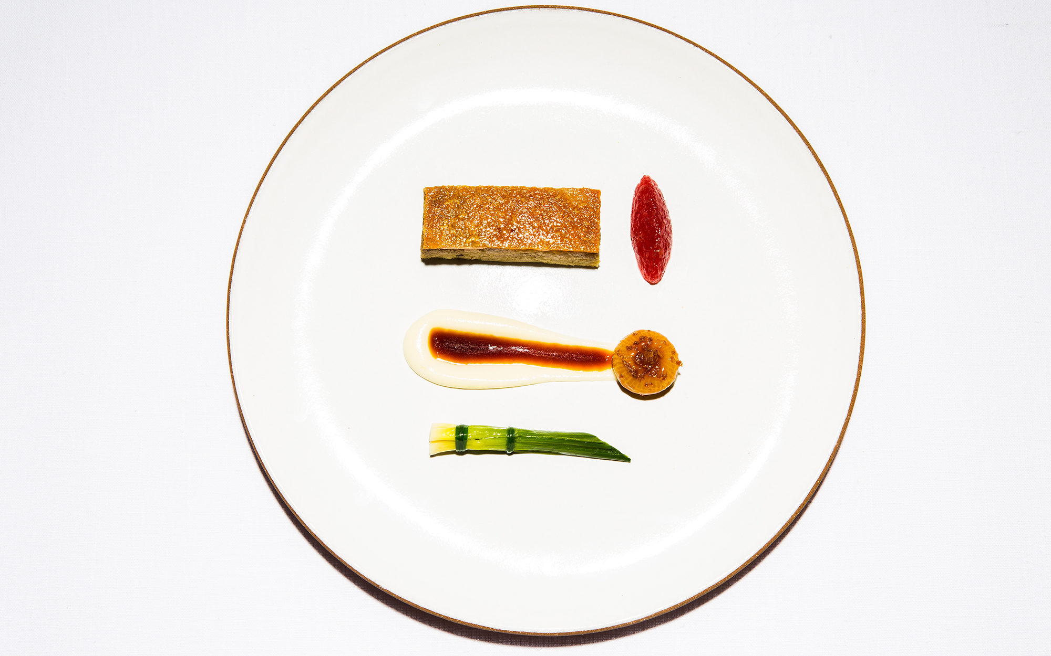
Image 1. Example of a fancy meal being artistically placed onto an expensive plate by another person.
There may be something lost in the experience of receiving food from a robot rather than from the hands of a person, or there may be something gained in how novel, intricate, and smoothly the robot operates. With this design, not only do we create a unique dining experience where production costs drop and efficiency increases, we also change the experience of ordering and eating a food typically made and served in public, social experiences.

RELATED WORK
While there have been many food related projects similar to The Taco Box, The Taco Box fulfills a niche of personal, taco creating machines that has not been done by a competing machine. Similar Products are either Prepared Food Dispensers, which contain premade meals that are distributed. Prepared Food Dispensers give users less agency over the meal they get from the machine. Another similar product archetype is the Fully Automated Restaurant. The major difference between The Taco Box and a Fully Automated Restaurant is that The Taco Box is the demographic the product is attempting to reach. Fully Automated Restaurants are intended as an alternative to traditional restaurants, which attempts to cut out a human chef and staff in place of a series of devices. They look to automate the full order to plate process. The Taco Box however seeks to reach a smaller more personal audience, and streamline the assembly process. The Taco Box does not seek to replace restaurants. The last similar product type are other Personal Food Preparation Devices. These devices are intended to assemble foods for smaller audiences, but none of these devices create tacos.
Prepared Food Dispensers
Pizza Vending Machine
This device houses up to 70 ready-to-eat pizzas. It can heat up the food or dispense the food cold, depending on what option the user chooses, and uses a vending-machine like mechanism to retrieve the food from a designated slot. Although the process of serving the food is similarly automated to our design, our prototype emphasizes live assembly of the food in front of the user.
Full Automated Restaurants
Spyce
Spyce has automated a full restaurant and can serve a variety of salads and mixed cooked foods. While Spyce is designed to be used for a full sit-down restaurant, the Taco Box hopes to reach an audience interested in faster grab and go food.
Eatsa
Eatsa was similar to Spyce in that it was intended to be a fully automated restaurant that made fast casual food. While this is closer to the Taco Box thematically than Spyce, Taco Box does not intend to target restaurant goers, and looks to serve smaller audiences faster.
Taco Bell Taco Maker
Designed by Taco Bell to automate and speed up the Taco Making process, this serves as proof that taco making machines work. Our design is not intended for restaurant or mass production use, but looks to serve at a smaller and more personal level.
Personal Food Preppers
Automatic Tortilla Maker
Creates taco tortillas which are then hand topped. The Taco Box intends to automate the other half of the process, creating the rest of the taco from premade and pre prepared ingredients.
Burger Conveyor Belt
Dispenses and builds a burger for a user with user specified toppings. This device is more precise than the Taco Box, as ingredients are placed in specific locations on the plate. However, the Burger Conveyor Belt is also large and clunky, and takes up more space than the Taco Box. While the Burger Conveyor Belt takes up a full wall from table to ceiling, the Taco Box is intended to be slightly more compact.
Kolice Automatic Donut Making Machine
In addition to making a different food, the Kolice Automatic Donut Making Machine pours ingredients into a mold that then gets fried and dispensed. Our ingredients would have to be pre-cooked, but would have a greater variety in choices for what can and will be dispensed. The Taco Box will also have the capability to make a full meal, which the Kolice Automatic Donut Making Machine lacks.
Smart Barusa
While the nozzle system to dispense drinks will be similar to the systems the Taco Box uses to dispense fluidic components of tacos (i.e. salsa), the Smart Barusa dispenser exclusively deals with liquids. The Smart Barusa also assembles the drink internally and pours only the finished product. On the other hand, Taco Box will make the taco in front of users. We hope that watching the taco preparation will be part of the fun of using the Taco Box.

SYSTEM DESIGN
Folding: This aspect of the design addresses the point at which the tortilla is made into the taco shape, and if not, how else to shape it so ingredients do not fall loose. The desired endpoint for the folded shape is a U-shape, essentially bringing two sides of the circular tortilla together. We are considering three options. Our first option is folding at the beginning. If the taco is folded at beginning, the tortilla would move through the conveyor belt with less surface area to put ingredients/sauces on. Second, we are considering folding at end: if folded at end, the ingredients would be added onto a flat tortilla, and the tortilla would be shaped into a taco shape after all were added. Last, we are considering folding into “bowl” shape and flatten/ fold after: for this design, the tortilla travels through the conveyor in a slight bowl shape, simply for the sake of catching ingredients, but is then folded to final taco shape after ingredients are added.
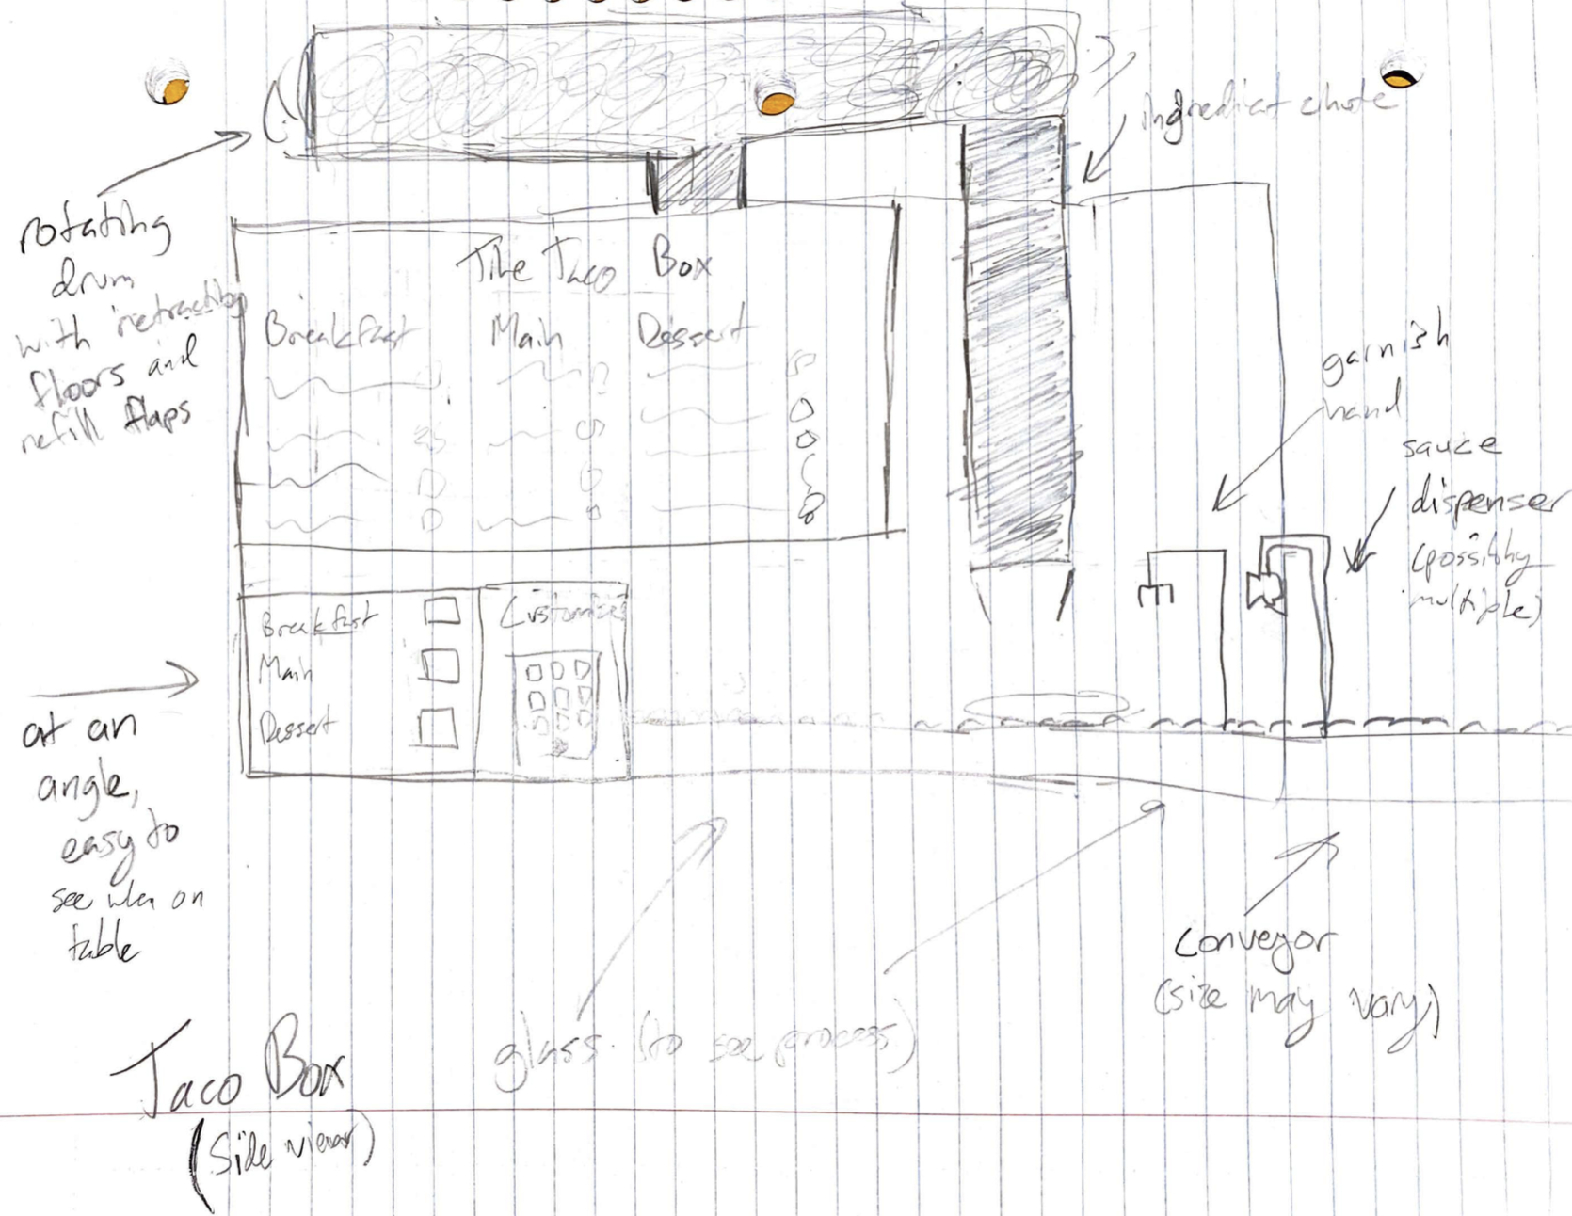
Figure 1. This illustration models the entire machine as it would look. Involved is different methods of grabbing and dispensing certain items used for the taco machine.
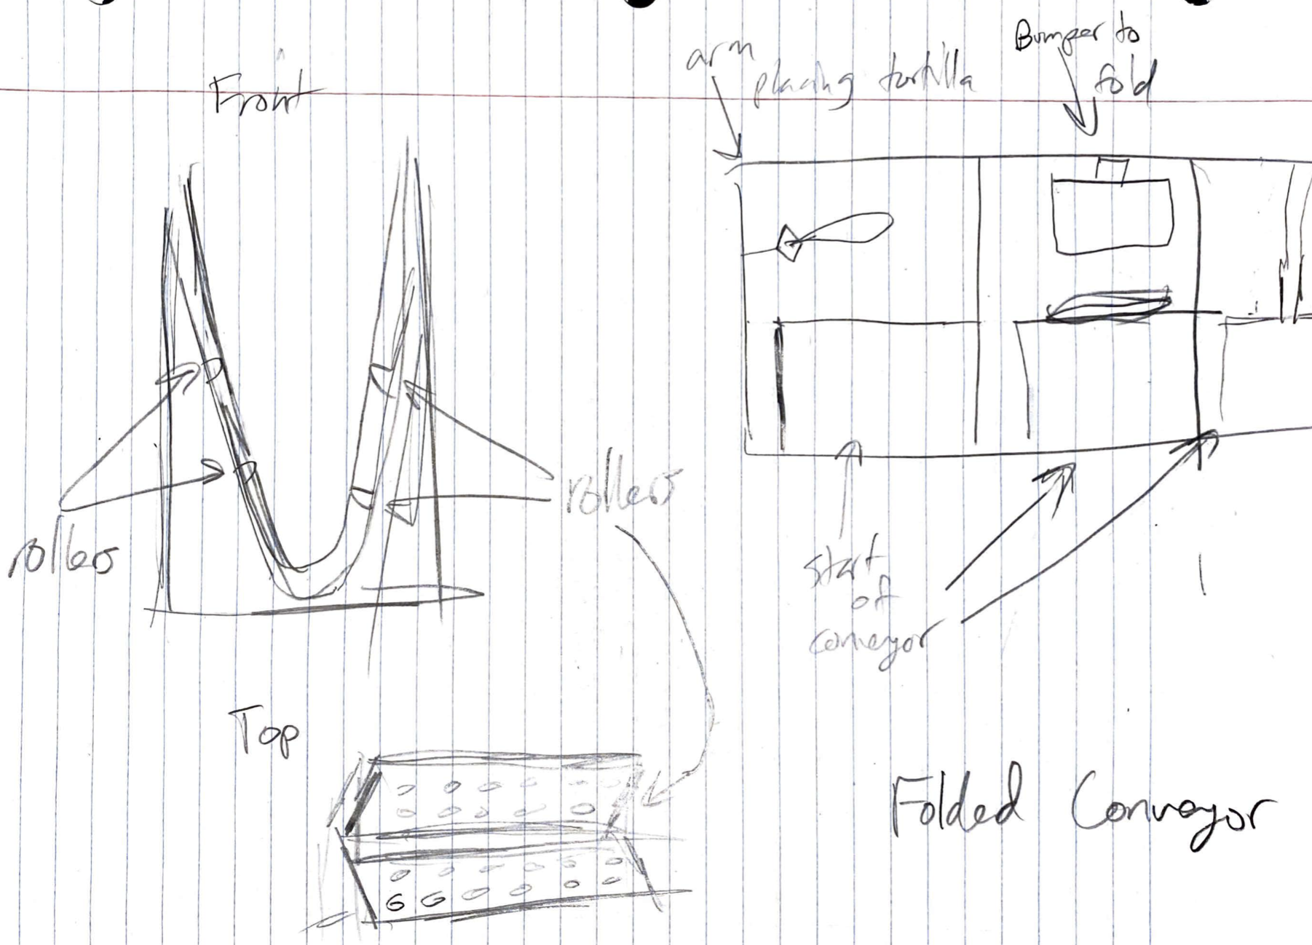
Figure 2. This figure displays how the tortilla roll would be folded at the beginning of the conveyor belt.
Ways to keep ingredients inside the taco: Since taco ingredients are messy, loose, and saucy, we need a way to best keep ingredients inside the tortilla, if possible. We considered the design options of (1) Bumpers on each side of preliminary taco bowl: This design features four bumper plates at a tilt, gently forcing the tortilla into a makeshift bowl as it travels across the conveyor (2)Bumpers around tortilla (if flat): If the tortilla remains flat, bumper plates on all sides of the tortilla help to contain ingredients. (3) Bumpers around pre-folded taco: assuming the taco is folded before entering the conveyor, this design only needs two bumper plates for the ends of the taco, so ingredients don’t spill from the lower sides.
Conveyor belt systems: The process of moving the taco through various stages means some sort of conveyor, progressor, or pushing system is needed. We considered (1) Rolling wheels: conveyor belt consists of rollers/wheels, on top of which the tortilla rolls along. Would be difficult to clean/lots of materials used / lots of mechanization (2) Moving surface: a large belt surface moves the tacos, which would make for smooth and continuous movement (3) Flipping pieces to propel forward: this design attaches flippable plates to push tacos forward, the belt itself doesn’t move. Overall, this mechanism can either be a continuous rolling belt, or it could be one flat surface that moves back/forth and resets between foods.
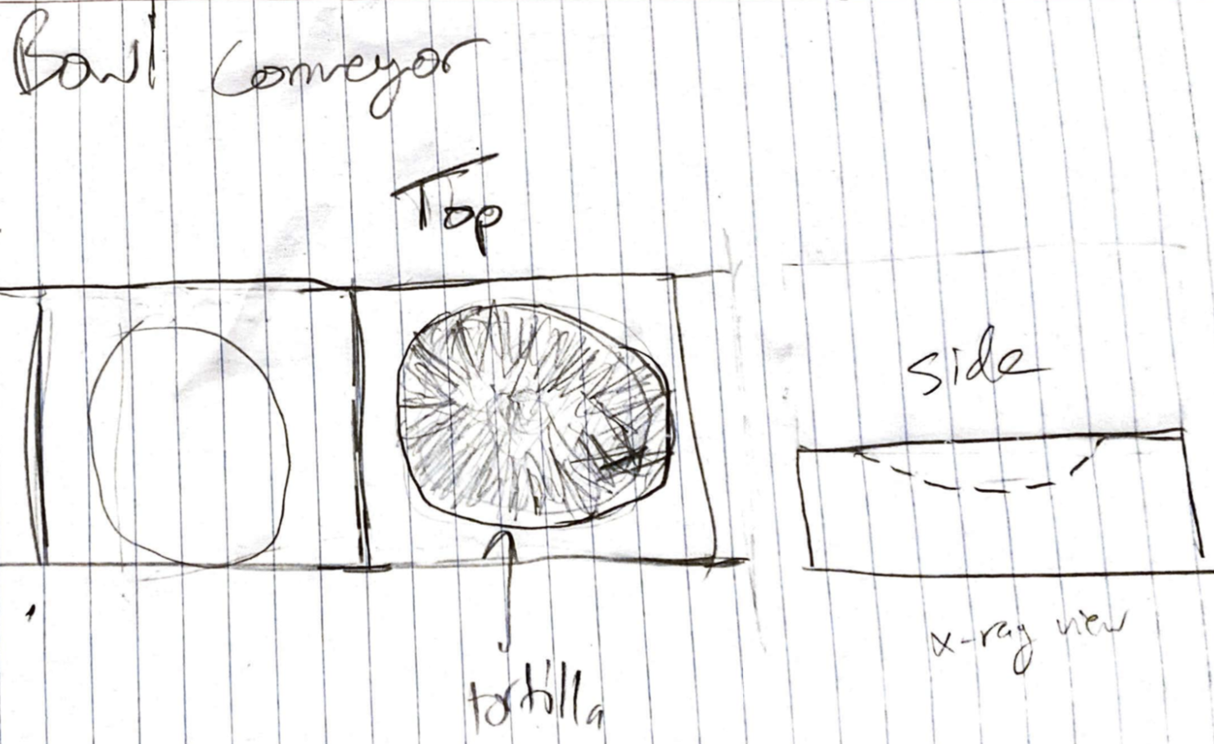
Figure 3. The top overview of the bowl conveyor as things would be placed inside the taco machine.

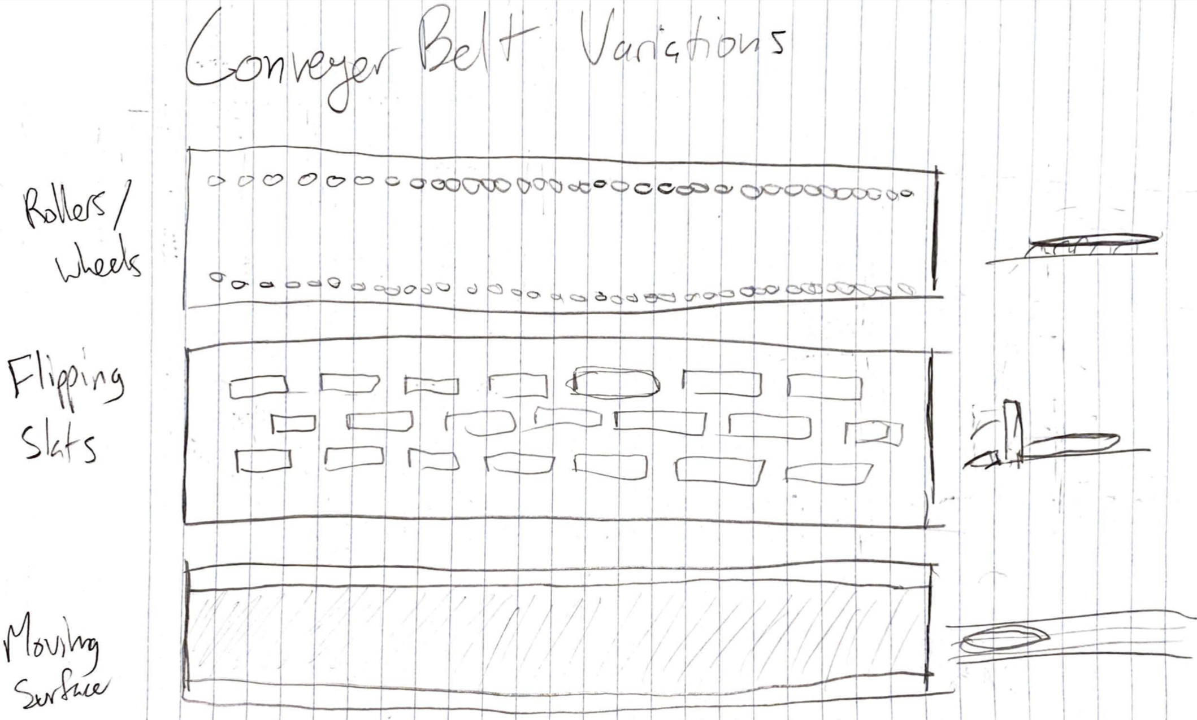
Figure 4. This figure demonstrates different variations of implementing a conveyor belt.
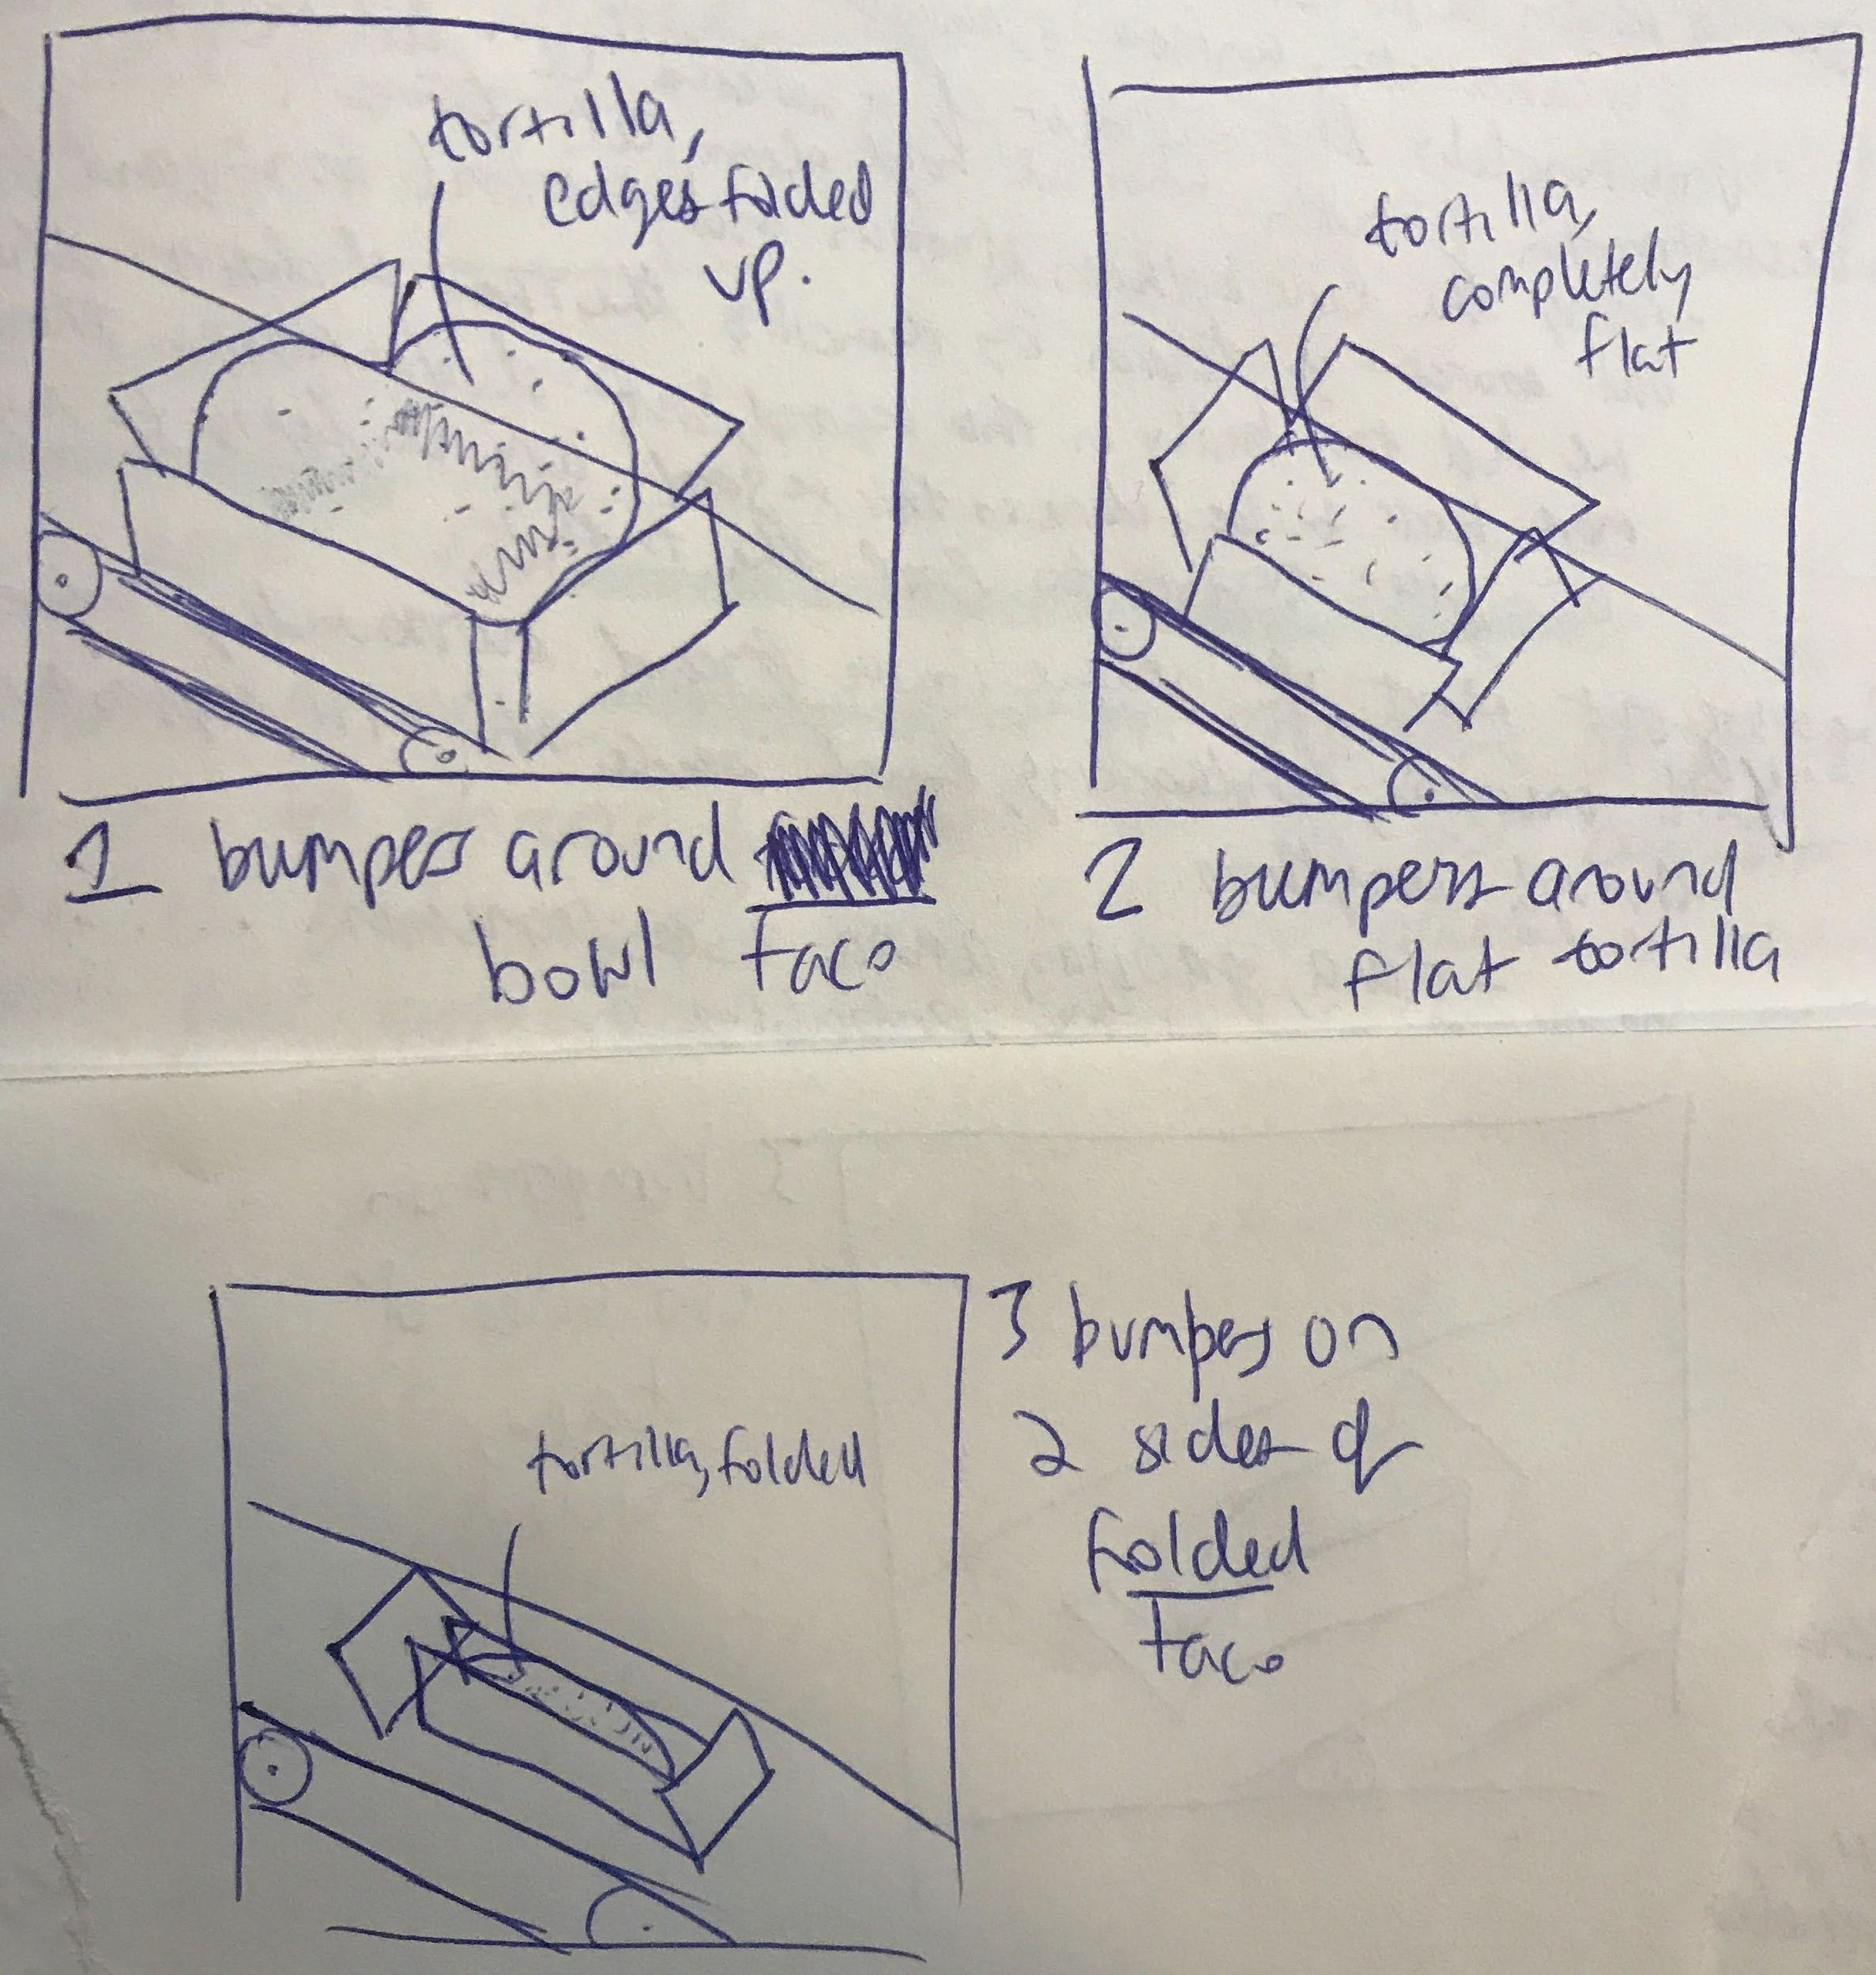
Figure 5. Example of the tortilla roll being folded preemptively using bumpers on all four sides.
Different mechanisms for switching ingredients: Since our design involves giving users choice between different ingredients, we need responsive mechanisms to switch between whatever options they choose. Design wise, we considered: (1) Precise pivoting arms: with multiple arms attached to one pivot point, each arm has a different ingredient container attached to it and when selected, rotates into position to release ingredients. (2) Trapdoor dropper with rotating drum on top: in this design, multiple ingredient cups are attached to a rotating trapdoor module that blocks all other cups from releasing ingredients other than the one selected. (3) Sauce nozzle(s): sauces are contained in tubes/nozzles and the nozzles become unblocked when the respective sauce is selected. (4) Scooper/ spoon arm: scooping arms locate correct ingredient bins, perform a scooping maneuver, and unscoop to release onto tortilla (5) Claw machine grabber arm: useful for dry/dense ingredients such as cheese, meat, or onions, this mechanism performs a contracting grab to scoop some ingredients from containers and release them onto the tortilla.
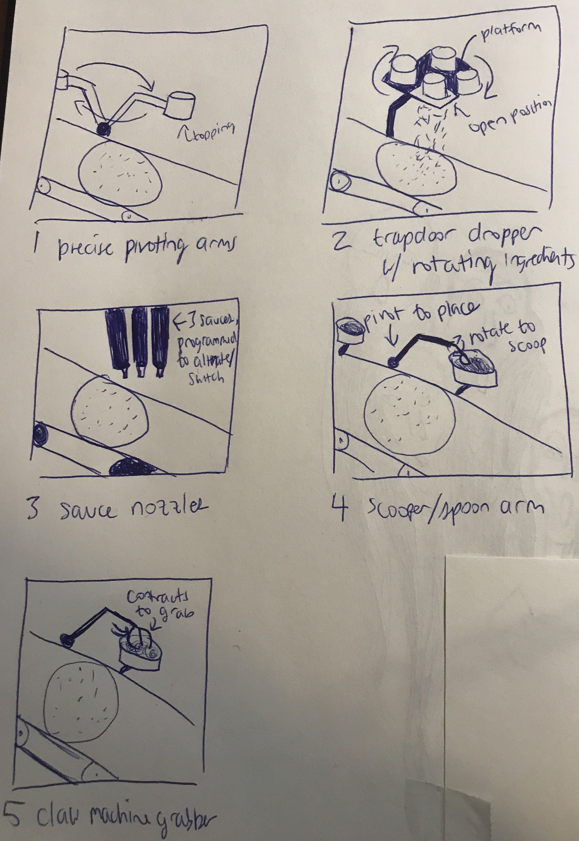
Figure 4. These sets of pictures demonstrate the different possible methods of distributing ingredients onto the tortilla roll before folding. 4.1 illustrates precise pivoting arms while 4.4 and 4.5 shows a similar arm mechanism but with a scooper or a grabber. 4.2 is a raised platform with a trapdoor. 4.3 is a sauce nozzle to squeeze sauce onto it.
Courses: The Taco Box is intended to represent a food truck in a miniaturized form. While a fully complete version of The Taco Box would be able to make a large variety of meals, for the scope of this prototype The Taco Box will have a more limited set of options. For the initial design, The Taco Box will be able to a traditional Mexican taco configuration. It will consist of a marinated protein, diced onion or another vegetable, a salsa or guacamole, and an herb garnish. That marinated protein could be chicken, pork or beef, and could be prepared in any one of the well-known preparations, such as al pastor, carne asada or carnitas. As stretch goals, we may consider implementing breakfast tacos with meat, eggs, and veggies and/or dessert tacos with a choice of chocolate or caramel sauce, bananas, and marshmellows.

REFERENCES
- http://pizzaatmllc.com/
- https://www.spyce.com/
- https://www.thrillist.com/eat/nation/taco-bell-tacos-maker-machine
- http://creator.rest/
- https://www.amazon.com/Kolice-Automatic-Machine-Doughnut-Counting/dp/B07FFS1W3G/
- https://sf.eater.com/2019/7/23/20706270/eatsa-closed-tech-company-starbucks-investment-brightloom
- https://cafexapp.com/
- https://www.smartbarusa.com/

PAGE SIZE and columns
On each page your material should fit within a rectangle of 7 x 9.25 in (18 x 23.5 cm), centered on a US letter page (8.5x11 in), beginning 0.75 in (1.9 cm) from the top of the page, with a 0.33 in (0.85 cm) space between two 3.3 in (8.4 cm) columns. Right margins should be justified, not ragged. Please be sure your document and PDF are US letter and not A4.

TYPESET TEXT
The styles contained in this document have been modified from the default styles to reflect ACM formatting conventions. For example, content paragraphs like this one are formatted using the Normal style.

Title and Authors
Your paper’s title, authors, and affiliations should run across the full width of the page in a single column 7 in (17.8 cm) wide. The title should be in Helvetica or Arial 18-point bold (the Title style in this document). Authors’ names should be in Times New Roman or Times Roman 12-point bold (Author Name style), and affiliations in the font as 12-point regular (Author Affiliation style).
To position names and addresses, use a single-row table with invisible borders, as in this document. Alternatively, if only one address is needed, use a centered tab stop to center all name and address text on the page; for two addresses, use two centered tab stops, and so on. For more than three authors, you may have to place some address information in a footnote, or in a named section at the end of your paper. Leave one 10-point line of white space below the last line of affiliations.

Adding and Removing Author Fields Above
If you need a 4th block for an additional author with a different affiliation, click on the table, click “layout” under “table tools”, and click “insert left” or “insert right”. Then right-click anywhere on the table, click “Table Properties”, and within the “Table” tab, click the tab box for “Preferred Width” and enter “7”.
If you need author blocks for only 1 or 2 authors, you should remove one column from the table. Right-click in the unwanted cell, click “Delete Cell”, click “Delete entire column”, then click “OK”. Repeat if necessary.

Abstract and Keywords
Every submission should begin with an abstract of about 150 words, followed by a set of keywords. The abstract and keywords should be placed in the left column of the first page under the left half of the title. The abstract should be a concise statement of the problem, approach, and conclusions of the work described. It should clearly state the paper’s contribution to the field of HCI.

Normal or Body Text
Please use 10-point Times New Roman or Times Roman font (the Normal style) or, if this is unavailable, another proportional font with serifs, as close as possible in appearance to Times New Roman 10-point. Other than Helvetica or Arial headings, please use sans-serif or non-proportional fonts only for special purposes, such as source code text.

First Page Copyright Notice
You will need to update the ACM copyright block with the assigned text and DOI during the ACM rightsreview process (see page 1, bottom of column 1). Accepted papers will be distributed in the conference publications. They will also be placed in the ACM Digital Library, where they will remain accessible to thousands of researchers and practitioners worldwide. ACM’s copyright and permissions policy is here:
http://acm.org/publications/policies/copyright_policy

Subsequent Pages
On pages beyond the first, start at the top of the page and continue in double-column format. The two columns on the last page should be of approximately equal length.

Figure 1. Insert a numbered caption below each figure/table. Times New Roman 9-point bold. One-line captions should be centered; multi-line should be justified.

References and Citations
Use a numbered list of references at the end of the article, ordered alphabetically by last name of first author, and referenced by numbers in brackets [1, 3, 4].
Objects | Caption – pre-2002 | Caption – 2003 and afterwards
Tables | Above | Below
Figures | Below | Below
Table 1. Table captions should be placed below the table. We recommend table lines be 1 point, 25% black. Minimize use of unnecessary table lines.
Your references should be published materials accessible to the public. Internal technical reports may be cited only if they are easily accessible (i.e., you provide the address for obtaining the report within your citation) and may be obtained by any reader for a nominal fee. Proprietary information may not be cited. Private communications should be acknowledged in the main text, not referenced (e.g., “[Borriello, personal communication]”).
References should be in ACM citation format: http://acm.org/publications/submissions/latex_style. This includes citations to internet resources [1, 4, 8] according to ACM format, although it is often appropriate to include URLs directly in the text, as above.

SECTIONS
The heading of a section should be in Helvetica or Arial 9-point bold, all in capitals (Heading 1 style). Sections should not be numbered.

Subsections
Headings of subsections should be in Helvetica or Arial 9-point bold with initial letters capitalized (Heading 2 style). For sub-sections and sub-subsections, a word like the or of is not capitalized unless it is the first word of the heading.

Sub-subsections
Headings for sub-subsections should be in Helvetica or Arial 9-point italic with initial letters capitalized (Heading 3 style).

FIGURES/CAPTIONS
Place figures and tables at the top or bottom of the appropriate column or columns, on the same page as the relevant text (see Figure 1). A figure or table may extend across both columns to a maximum width of two columns, or 17.78 cm (7 in.).
Captions should be Times New Roman 9-point bold (Caption style). They should be numbered (e.g., “Table 1” or “Figure 2”), centered (if one line) otherwise justified, and placed beneath the figure or table. The words “Figure” and “Table” should be spelled out (e.g., “Figure” rather than “Fig.”) wherever they occur.
All figures should also include alt text for improved accessibility. In Word, right click the figure, and select Format Picture | Layout | Alt Text). Papers and notes may use color figures, which are included in the page limit; the figures must be usable when printed in black-and-white in the proceedings.
The paper may be accompanied by short video figure (we recommend staying within five minutes in length). However, the paper should stand on its own without the video figure, as the video may not be available to everyone who reads the paper.

Inserting Images
Occasionally MS Word generates larger-than-necessary PDF files when images inserted into the document are manipulated in MS Word. To minimize this problem, use an image editing tool to resize the image at the appropriate printing resolution (usually 300 dpi), and then insert the image into Word using Insert | Picture | From File.

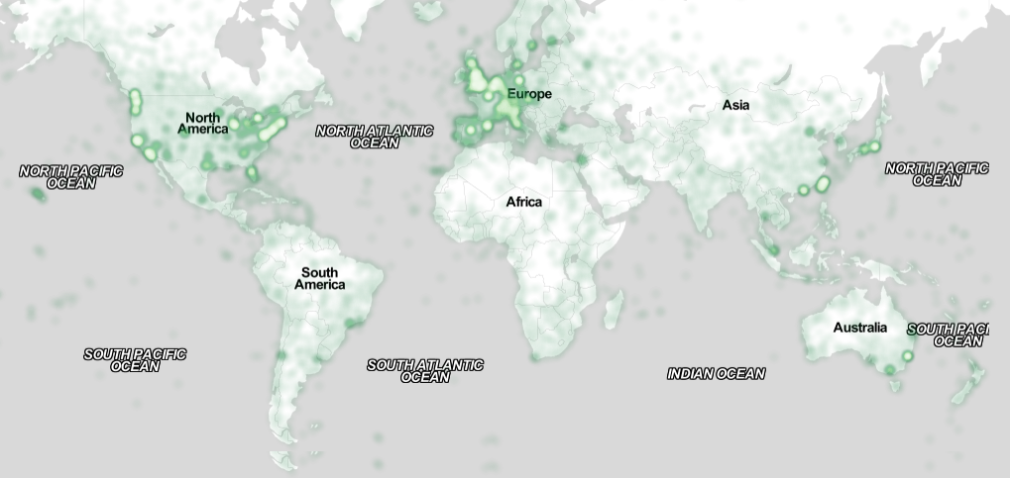
Figure 2. Sample of a wide figure. Be sure to place at the top or bottom of the page. Ensure that important information is legible in both black-and-white and color printing. Image: CC-BY-ND ayman on Flickr.

Table Style
The text of tables will format better if you use the Table Text style (as in Table 1). If you do not use this style, then you may want to adjust the vertical spacing of the text in the tables. To adjust the spacing of text in a table in Word, use Home | Paragraph | Indents and Spacing. Generally, text in each field of a table will look better if it has equal amounts of spacing above and below it, as in Table 1. Table captions should be placed below the table. We recommend table lines be 1 point, 25% black. Minimize use of unnecessary table lines.
For improved accessibility, header rows of tables should be marked. In Word, right-click a header row, and select Table Properties | Row | Repeat as header…

QUOTATIONS
Quotations may be italicized when “placed inline”.
Longer quotes, when placed in their own paragraph, need not be italicized or in quotation marks when indented.

LANGUAGE, STYLE AND CONTENT
The written and spoken language of SIGCHI is English. Spelling and punctuation may use any dialect of English (e.g., British, Canadian, US, etc.) provided this is done consistently. Hyphenation is optional. To ensure suitability for an international audience, please:
- Write in a straightforward style.
- Try to avoid long or complex sentence structures.
- Use common and basic vocabulary (e.g., use the word “unusual” rather than the word “arcane”).
- Briefly define or explain all technical terms that may be unfamiliar to readers.
- Explain all acronyms the first time they are used in your text—e.g., “Digital Signal Processing (DSP)”.
- Explain local references (e.g., not everyone knows all city names in a particular country).
- Explain “insider” comments. Ensure that your whole audience understands any reference whose meaning you do not describe (e.g., do not assume that everyone has used an Android phone, or a particular application).
- Explain colloquial language and puns. Understanding phrases like “red herring” may require a local knowledge of English. Humor and irony are difficult to translate.
- Use unambiguous forms for culturally localized concepts, such as times, dates, currencies, and numbers (e.g., “1-5- 97” or “5/1/97” may mean 5 January or 1 May, and “seven o’clock” may mean 7:00 am or 19:00). For currencies, indicate equivalences: “Participants were paid ₩22, or roughly US$29.”
- Be careful with the use of gender-specific pronouns (he, she) and other gendered words (chairman, manpower, man-months). Use inclusive language that is gender-neutral (e.g., she or he, they, s/he, chair, staff, staff-hours, person-years). See the Guidelines for Bias-Free Writing for further advice and examples regarding gender and other personal attributes [9]. Be particularly aware of considerations around writing about people with disabilities.
- If possible, use the full (extended) alphabetic character set for names of persons, institutions, and places (e.g., Grønbæk, Lafreniére, Sánchez, Nguyễn, Universität, Weißenbach, Züllighoven, Århus, etc.). These characters are already included in most versions and variants of Times, Helvetica, and Arial fonts.

Accessibility
The Executive Council of SIGCHI has committed to making SIGCHI conferences more inclusive for researchers, practitioners, and educators with disabilities. As a part of this goal, the all authors are asked to work on improving the accessibility of their submissions. Specifically, we encourage authors to carry out the following five steps:
- Add alternative text to all figures
- Mark table headings
- Generate a tagged PDF
- Verify the default language
- Set the tab order to “Use Document Structure”
For more information and links to instructions and resources, please see: http://chi2016.acm.org/accessibility.

Page Numbering, Headers, and Footers
Your final submission should not contain footer or header information at the top or bottom of each page. Specifically, your final submission should not include page numbers. Initial submissions may include page numbers, but these must be removed for camera-ready. Page numbers will be added to the PDF when the proceedings are assembled.

Producing and testing PDF files
We recommend that you produce a PDF version of your submission well before the final deadline. Your PDF file must be ACM DL Compliant. The requirements for an ACM Compliant PDF are available at:
www.scomminc.com/pp/acmsig/ACM-DL-pdfs-requirements.htm
When creating your PDF from Word, ensure that you generate a tagged PDF from improved accessibility. This can be done by using the Adobe PDF add-in, also called PDFMaker. Select Acrobat | Preferences from the ribbon and ensure that “Enable Accessibility and Reflow with tagged Adobe PDF” is selected. You can then generate a tagged PDF by selecting “Create PDF” from the Acrobat ribbon. Test your PDF file by viewing or printing it with the same software the publisher will use, Adobe Acrobat Reader Version 10, which is widely available at no cost. Note that most reviewers will use a North American/European version of Acrobat Reader, so please check your PDF accordingly.

Conclusion
It is important that you write for the SIGCHI audience. Please read previous years’ proceedings to understand the writing style and conventions that successful authors have used. State clearly what you have done, not merely what you plan to do, and explain how your work is different from previously published work, i.e., the unique contribution that your work makes to the field. Please consider what the reader will learn from your submission, and how they will find your work useful. If you write with these questions in mind, your work is more likely to be successful, both in being accepted into the conference, and in influencing the work of our field.

ACKNOWLEDGMENTS
Sample text: We thank all the volunteers, and all publications support and staff, who wrote and provided helpful comments on previous versions of this document. Authors 1, 2, and 3 gratefully acknowledge the grant from NSF (#1234-2012-ABC). This is just an example.

References format
References must be the same font size as other body text. References should be in alphabetical order by last name of first author. Example reference formatting for individual journal articles [3], articles in conference proceedings [7], books [9], theses [10], book chapters [11], an entire journal issue [6], websites [1, 4], tweets [1], patents [5], and online videos [8] is given here. This formatting is a slightly edited version of the format automatically generated by the ACM Digital Library (http://dl.acm.org) as “ACM Ref”. More details of reference formatting are available at:
http://www.acm.org/publications/submissions/latex_style
Note that the Hyperlink style used throughout this document uses blue links; however, URLs that appear in the references section may appear in black.

REFERENCES
- Please use square brackets around your references numbers for the references list.
@_CHINOSAUR. 2014. VENUE IS TOO COLD. #BINGO #CHI2016. Tweet. (1 May, 2014). Retrieved February 2, 2014 from https://twitter.com/_CHINOSAUR/status/461864317415989248
- ACM. How to Classify Works Using ACM’s Computing Classification System. 2014. Retrieved August 22, 2014 from http://www.acm.org/class/how_to_use.html
- Anna Cavender, Shari Trewin, Vicki Hanson. 2014. Accessible Writing Guide. Retrieved August 22, 2014 from http://www.sigaccess.org/welcome-to-sigaccess/resources/accessible-writing-guide/
- Morton L. Heilig. 1962. Sensorama Simulator, U.S. Patent 3,050,870, Filed January 10, 1961, issued August 28, 1962.
- Jofish Kaye and Paul Dourish. 2014. Special issue on science fiction and ubiquitous computing. Personal Ubiquitous Comput. 18, 4 (April 2014), 765-766. http://dx.doi.org/10.1007/s00779-014-0773-4
- Scott R. Klemmer, Michael Thomsen, Ethan Phelps-Goodman, Robert Lee, and James A. Landay. 2002. Where do web sites come from?: capturing and interacting with design history. In Proceedings of the Conference on Human Factors (CHI '02), 1-8. http://doi.acm.org/10.1145/503376.503378
- Psy. 2012. Gangnam Style. Video. (15 July 2012.). Retrieved August 22, 2014 from https://www.youtube.com/watch?v=9bZkp7q19f0
- Marilyn Schwartz. 1995. Guidelines for Bias-Free Writing. Indiana University Press.
- Ivan E. Sutherland. 1963. Sketchpad, a Man-Machine Graphical Communication System. Ph.D Dissertation. MIT, Cambridge, MA.
- Langdon Winner. 1999. Do artifacts have politics? In The Social Shaping of Technology (2nd. ed.), Donald MacKenzie and Judy Wajcman (eds.). Open University Press, Buckingham, UK, 28-40.

